**This FAANG Name Will Soon Accept Microcurrency Payments**

We’re closing out the week in the green.

At the time of writing, **Bitcoin (BTC)** is at $32,241 and **Ethereum (ETH)** is at $2,051.

You know, I always say that the true intended purpose of microcurrencies is to replace fiat paper.

We’ve already seen many companies and sports organizations begin accepting digital payments.

Well now, one of the biggest companies on the planet is planning to do so as well.

The disruptive juggernaut who changed the online shopping experience forever, Amazon, is entering the scene.

**Amazon’s New Executive Position for Microcurrencies**

Amazon recently posted a job listing on their website.

The position is titled “Digital Currency and Blockchain Product Lead” and is focused on payments.

Here’s the introductory portion of their job listing:

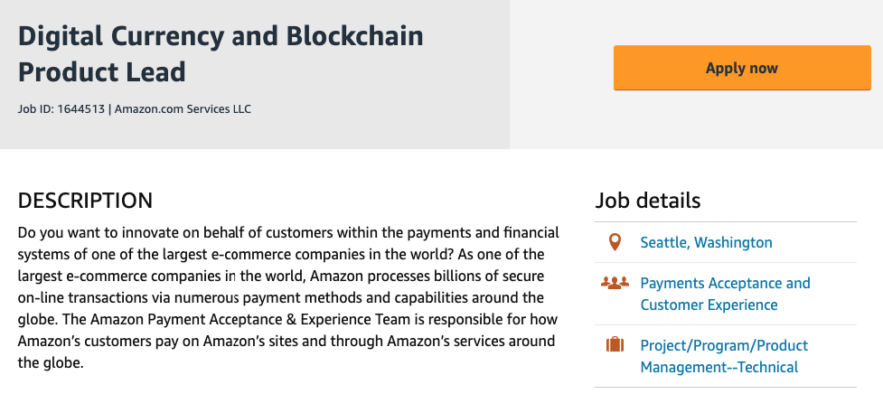

Taken from [Amazon.jobs](http://amazon.jobs)

As you can tell, they are focusing on *accepting* digital currency payments.

This is *big* news, folks!

Everyone in America uses Amazon.

Now that they’re obviously planning to accept digital coins, it won’t be long before you can spend your **Bitcoin (BTC)** at Amazon.

The job listing says that this position's most important role is to, *“Own the vision and strategy for Amazon’s Digital Currency and Blockchain strategy and product roadmap.”*

When an influential company like Amazon accepts microcurrency payments, it will cause a ripple effect in the entire e-commerce sector.

Since Amazon is such a big, established company, everyday shoppers will grow more trusting of digital coins.

They’ll think to themselves, *“Well if Amazon is accepting microcurrencies, they must be the real deal.”*

Digital coins are slowly but surely replacing fiat paper.

Which is why it’s no surprise that we continue to see new **BTC** ATMs in America.

**More Bitcoin ATMs are Coming to the US**

Bitcoin Depot has just secured a long-term partnership with Circle K, the convenience store chain.

The company manufactures **Bitcoin (BTC)** ATMs.

You might have seen one yourself, they look like this:

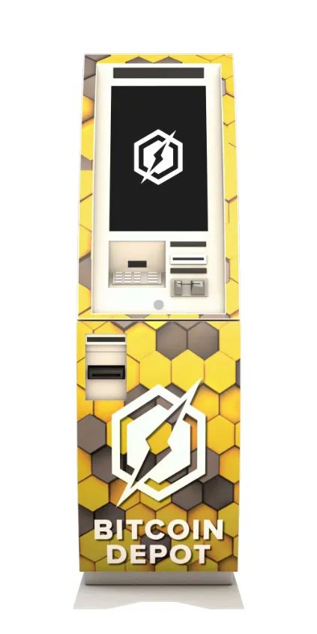

Taken from [Bitcoindepot.com](http://bitcoindepot.com)

They already have 700 ATMs across 30 states.

CEO Brandon Mintz also revealed that he plans to have 6,000 ATMs across North America by the end of this year.

He commented on the new partnership with Circle K, saying:

*“We feel that the Circle K brand has a wide and diverse customer base with people from all walks of life visiting these stores.”*

I’ll be watching Circle K closely now to see how these ATMs affect their business.

While **BTC** ATMs are popping up in America, one African nation is scheduling their central bank digital currency’s (CBDC) launch date.

**Nigeria Has Multiple Levels of Microcurrency Usage**

The nation of Nigeria has been welcoming microcurrencies with open arms.

Their [**street vendors**](https://moneymappress.com/subscription/microcurrency-trader/alerts/african-street-vendors-are-doing-business-in-bitcoin/) are already using **Bitcoin (BTC)** to pay for their goods because it’s more profitable to use **BTC** than fiat.

Their SEC has declared that [**all digital coin assets**](https://moneymappress.com/subscription/microcurrency-trader/alerts/africas-largest-country-says-all-digital-assets-are-securities/) are securities.

And when Nigerian banks shut down the fundraiser accounts of The Feminist Coalition Group, this activist organization replaced their large amount of funds with **BTC**.

They said they couldn’t care less that the banks [**stole all the fund money**](https://moneymappress.com/subscription/microcurrency-trader/alerts/cftc-chairman-praises-this-digital-coin/) because it was Nigeria’s fake, fiat paper - ha!

Now, the Central Bank of Nigeria has scheduled October 1, 2021 as the launch date of their central bank digital currency (CBDC).

With microcurrencies so deeply rooted in Nigeria’s economy, I’m looking forward to see how their economy grows - especially compared to surrounding nations.

If they prosper, you better bet that their neighbors will begin adopting microcurrencies as well.

We are seeing the digital economy develop right before our eyes and I will be here next week with the most important updates from micro-space.

Until then,



Tom Gentile

America’s #1 Pattern Trader